User Manual

Program: Homework 6.cpp

This program is a database that lets you get the actors for a movie, or the movies for an actor, all the info is connected using linked lists.

To run the program double click on the file Homework 6.exe, or open Homework 6.cpp with Microsoft Visual Studio 2010 or above and hit Control F5. A console window will appear asking you to pick an option. Enter the specified object. Hit enter after typing your input for each field. Upon finish it will print your info. Press any key to terminate the program when you are done.

System Manual

Program: Homework 5.cpp

This program uses linked lists to create an interwoven database of information that is drawn based on a variety of reference points. It takes advantage of the node and list classes given by the teacher.

The user is expected not to use special characters that C++ will not recognize..

Test Log

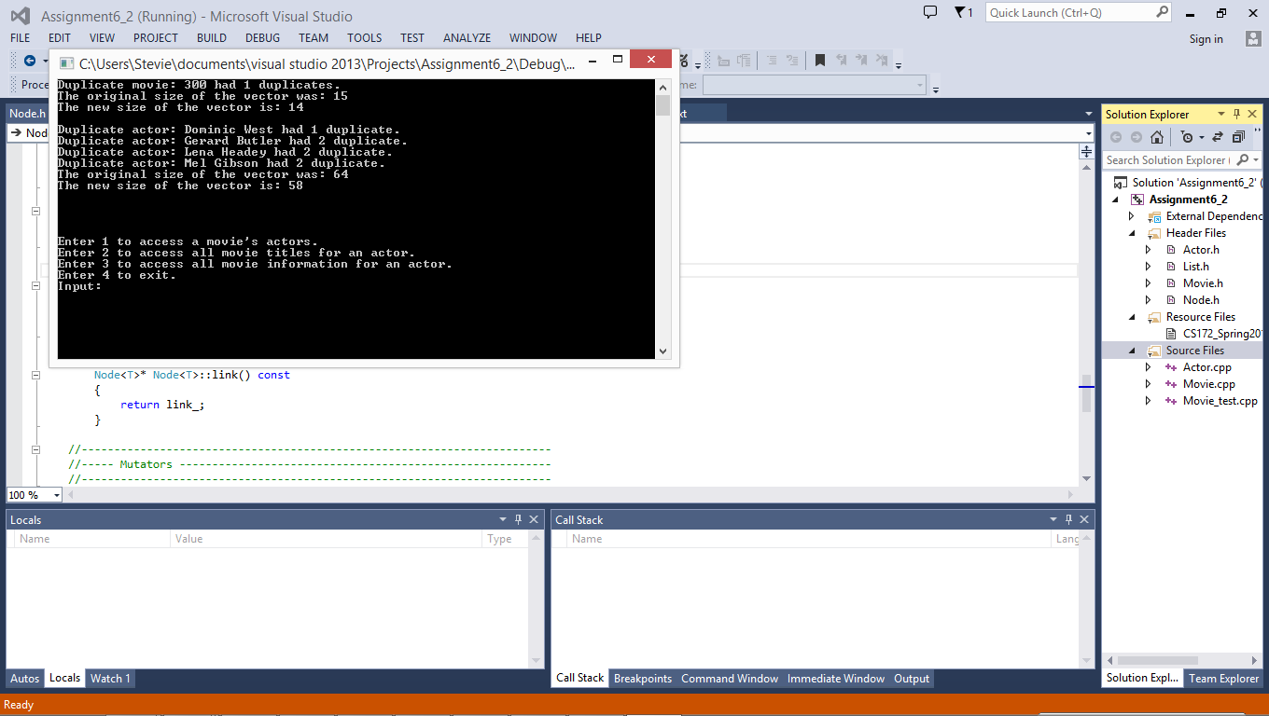

The program works properly, prompting the user information, sorting lists, and taking care of duplicates.